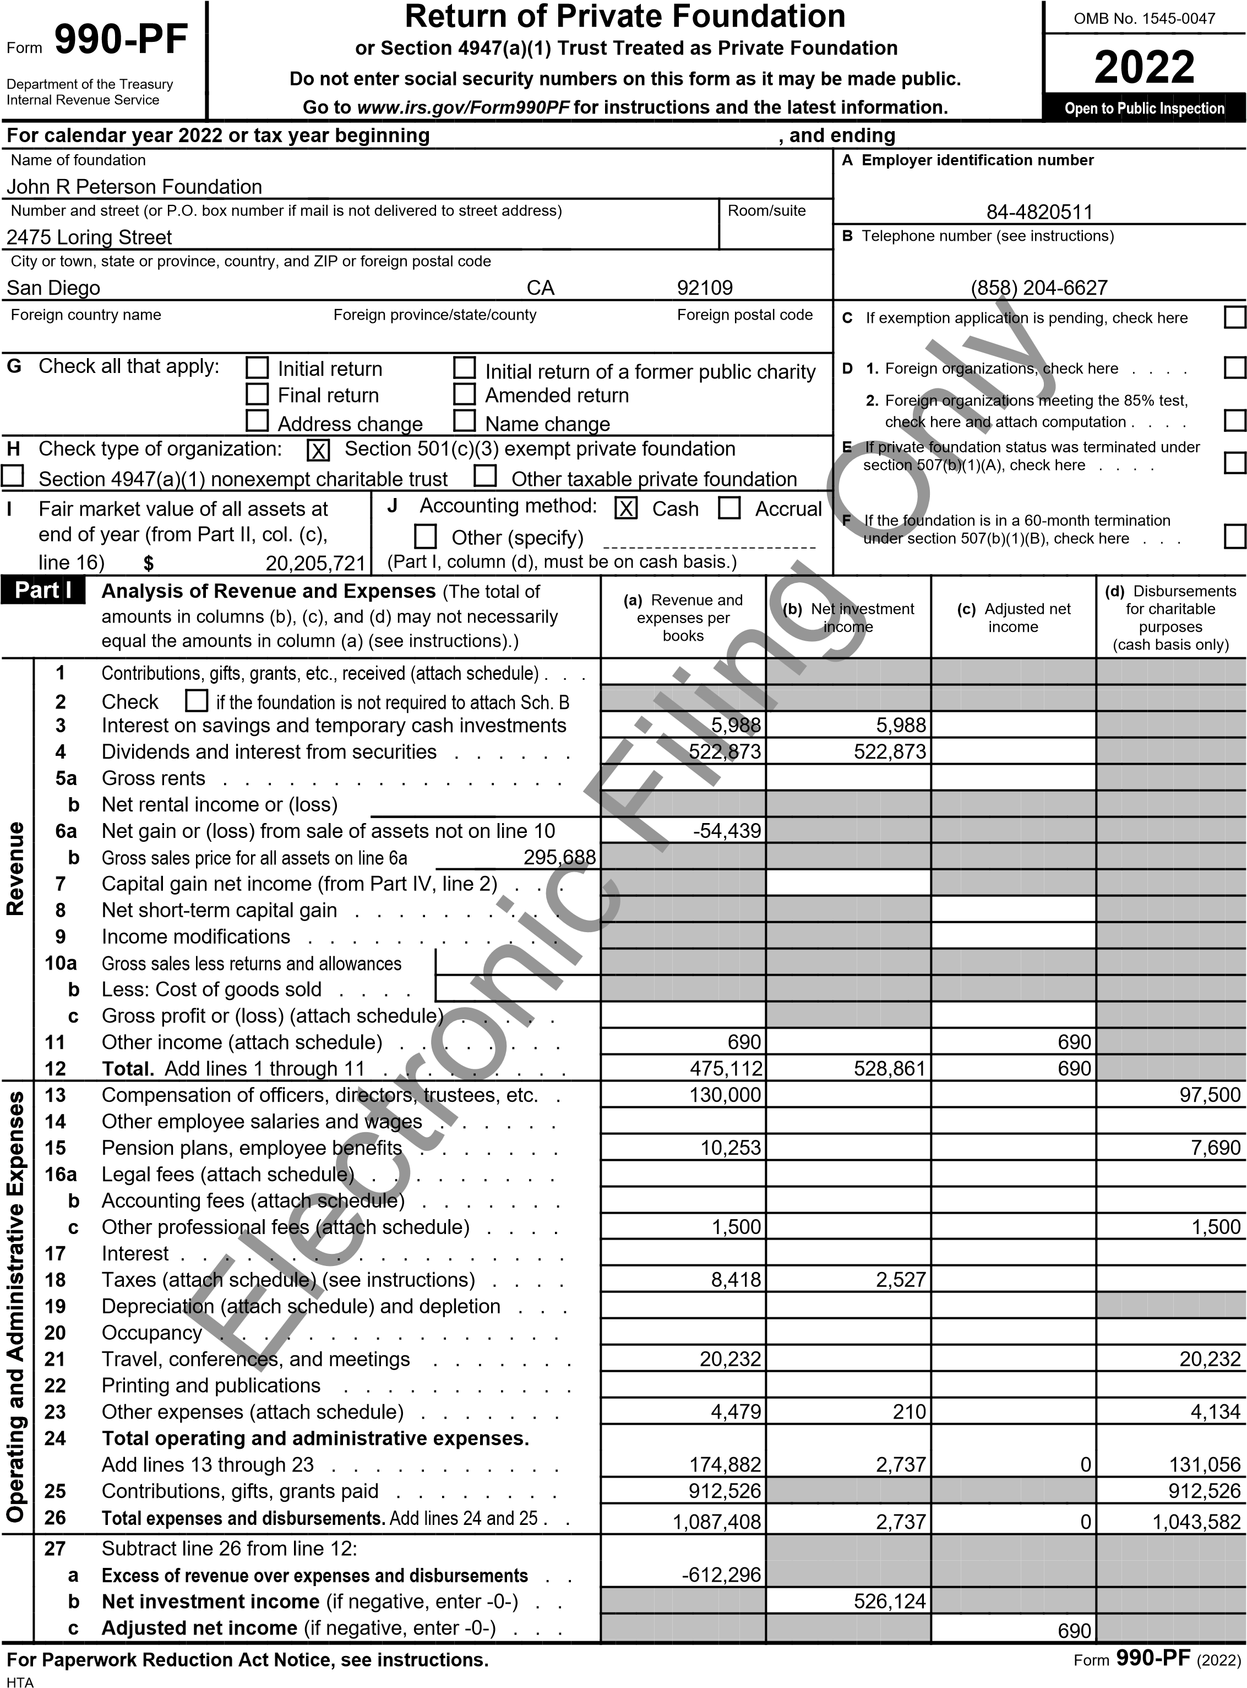

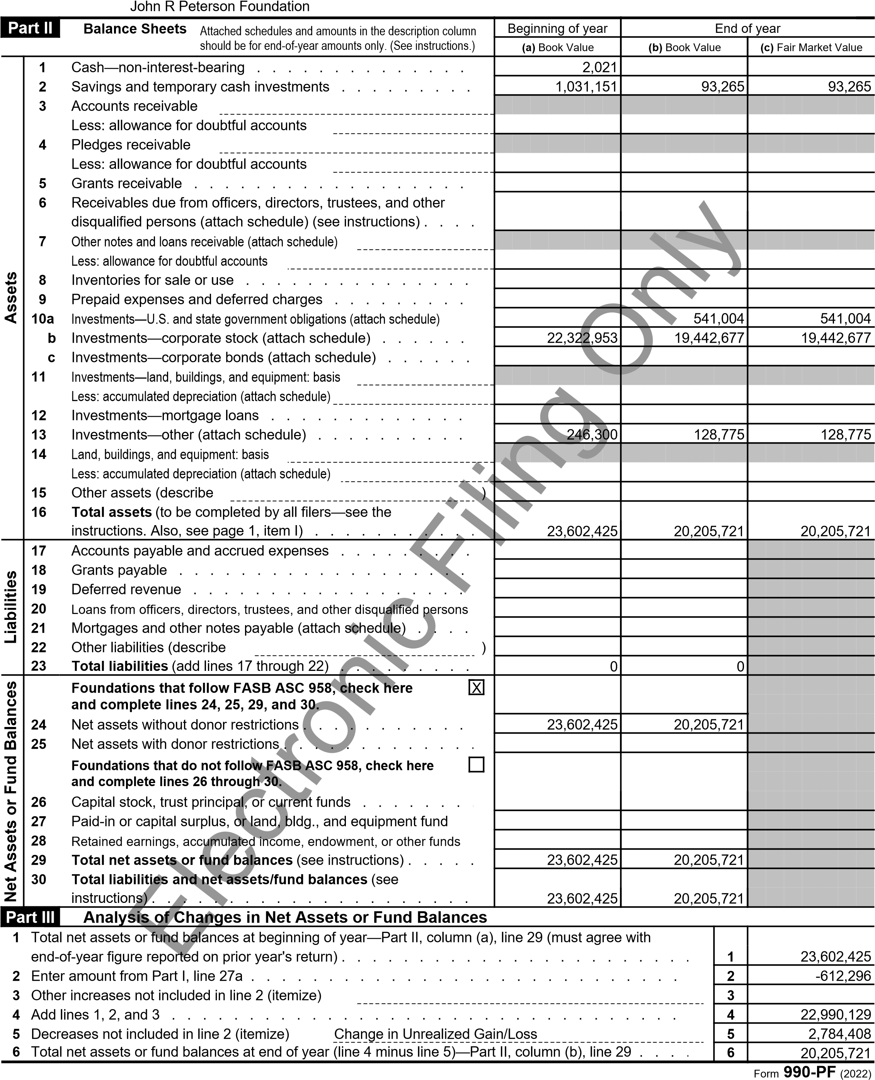

John R Peterson Foundation

|  |  |  |  |  |  |  |  |  |  |  |  |  |  |  |
| --- | --- | --- | --- | --- | --- | --- | --- | --- | --- | --- | --- | --- | --- | --- |
| **Part IV** | | **Capital Gains and Losses for Tax on Investment Income** | | | | | | | | | | | | |
|  | | **a)** List and describe the kind(s) of property sold (for example, real estate, 2-story brick warehouse; or common stock, 200 shs. MLC Co.) | | | | | **(b)** How acquired P—Purchase  D—Donation | | | **(c)** Date acquired (mo., day, yr.) | | | | **(d)** Date sold  (mo., day, yr.) |
| **1a** |  | Warner Brothers Discovery | | | | | P | | | 11/21/2019 | | | | 4/18/2022 |
| **b** | E | mbecta Corp | | | | | P | | | 11/21/2019 | | | | 4/8/2022 |
| **c** | C | harter Communications | | | | | P | | | 11/21/2019 | | | | 12/13/2022 |
| **d** | E | dwards Lifesiences | | | | | P | | | 12/13/2022 | | | | 12/13/2022 |
| **e** | K | yndryl Holdings | | | | | P | | | 12/21/2019 | | | | 12/13/2022 |
|  | **(** | **e)** Gross sales price | **(f)** Depreciation allowed (or allowable) | **(g)** Cost or other basis plus expense of sale | | | | | | **(h)** Gain or (loss)  ((e) plus (f) minus (g)) | | | | |
| **a** |  | 22 |  | 32 | | | | | | -10 | | | | |
| **b** |  | 12 |  | 11 | | | | | | 1 | | | | |
| **c** |  | 95,675 |  | 117,390 | | | | | | -21,715 | | | | |
| **d** |  | 181,990 |  | 181,990 | | | | | | 0 | | | | |
| **e** |  | 17,989 |  | 50,704 | | | | | | -32,715 | | | | |
|  |  | Complete only for assets showing gain in column (h) and owned by the foundation on 12/31/69. | | | | | | | | **(l)** Gains (Col. (h) gain minus col. (k), but not less than -0-) **or**  Losses (from col. (h)) | | | | |
|  | **(i** | **)** FMV as of 12/31/69 | **(j)** Adjusted basis as of 12/31/69 | **(k)** Excess of col. (i) over col. (j), if any | | | | | |
| **a** |  |  |  |  | | | | | | -10 | | | | |
| **b** |  |  |  |  | | | | | | 1 | | | | |
| **c** |  |  |  |  | | | | | | -21,715 | | | | |
| **d** |  |  |  |  | | | | | | 0 | | | | |
| **e** |  |  |  |  | | | | | | -32,715 | | | | |
| **2**  **3** | C  N  If  P | If gain, also enter in Part I, line 7  apital gain net income or (net capital loss)  If (loss), enter -0- in Part I, line 7 et short-term capital gain or (loss) as defined in sections 1222(5) and (6):  gain, also enter in Part I, line 8, column (c). See instructions. If (loss), enter -0- in art I, line 8 . . . . . . . . . . . . . . . . . . . . . . . . . . . . . . | | | | | | | | **2** | -54,439 | | | |
| **3** | 0 | | | |
| **Part V** | | **Excise Tax Based on Investment Income (Section 4940(a), 4940(b), or 4948—see instructions)** | | | | | | | | | | | | |
| **1a** Exempt operating foundations described in section 4940(d)(2), check here  Date of ruling or determination letter:  **b** All other domestic foundations enter 1.39% (0.0139) of line 27b. Exempt foreign organizations,  enter 4% (0.04) of Part I, line 12, col. (b) . . . . . . . . . . . . . . . . . . . . . . . . . . . . . . . . . . .   1. Tax under section 511 (domestic section 4947(a)(1) trusts and taxable foundations only; others, enter -0-) 2. Add lines 1 and 2 . . . . . . . . . . . . . . . . . . . . . . . . . . . . . . . . . . 3. Subtitle A (income) tax (domestic section 4947(a)(1) trusts and taxable foundations only; others, enter -0-) 4. **Tax based on investment income.** 5. Credits/Payments:   **a** 2022 estimated tax payments and 2021 overpayment credited to 2022 . . . **b** Exempt foreign organizations—tax withheld at source . . . . . . . . . **c** Tax paid with application for extension of time to file (Form 8868) . . . .  **d** Backup withholding erroneously withheld . . . . . . . . . . . . . .   1. Total credits and payments. Add lines 6a through 6d . . . . . . . . . . . . . . . . . . . . 2. Enter any **penalty** for underpayment of estimated tax. Check here 3. **Tax due.** If the total of lines 5 and 8 is more than line 7, enter 4. **Overpayment.** If line 7 is more than the total of lines 5 and 8, enter the  **11** Enter the amount of line 10 to be: **Credited to 2023 estimated tax** | | | | | Electronic Filing Only | and enter "N/A" on line 1.  **(attach copy of letter if necessary—see instructions)**          Subtract line 4 from line 3. If zero or less, enter -0- . . . . . .  **6a** 7,819 | | | | | |  | | |
|  | **1** | 7,313 | |
|  | | |
| **2** | 0 | |
| **3** | 7,313 | |
| **4** |  | |
| **5** | 7,313 | |
|  |  | |
| **amount owed** | | **6b** |  | | |
| **6c** |  | | |
| **6d** |  | | |
| if Form 2220 is attached  . . . . . . . . . . **amount overpaid** . . . . . 506 **Refunded** . . | | | | **7** | 7,819 | |
| **8** |  | |
| **9** | 0 | |
| **10** | 506 | |
| **11** | 0 | |

Form **990-PF** (2022)

Joh

|  |  |  |  |  |
| --- | --- | --- | --- | --- |
| **Part VI-A** | **Statements Regarding Activities** | | | |
| **1a** During the tax year, did the foundation attempt to influence any national, state, or local legislation or did it  participate or intervene in any political campaign? . . . . . . . . . . . . . . . . . . . . . . . . . **b** Did it spend more than $100 during the year (either directly or indirectly) for political purposes? See the instructions for the definition . . . . . . . . . . . . . . . . . . . . . . . . . . . . . . . . . .  If the answer is "Yes" to **1a** or **1b,** attach a detailed description of the activities and copies of any materials published or distributed by the foundation in connection with the activities. **c** Did the foundation file **Form 1120-POL** for this year? . . . . . . . . . . . . . . . . . . . . . . . **d** Enter the amount (if any) of tax on political expenditures (section 4955) imposed during the year:  **(1)** On the foundation. $  **(2)** On foundation managers. $  **e** Enter the reimbursement (if any) paid by the foundation during the year for political expenditure tax imposed on foundation managers. $   1. Has the foundation engaged in any activities that have not previously been reported to the IRS? . . . . . . If "Yes," attach a detailed description of the activities. 2. Has the foundation made any changes, not previously reported to the IRS, in its governing instrument, articles   of incorporation, or bylaws, or other similar instruments? If "Yes," attach a conformed copy of the changes . . . . . . .  **4a** Did the foundation have unrelated business gross income of $1,000 or more during the year? . . . . . . . **b** If "Yes," has it filed a tax return on **Form 990-T** for this year? . . . . . . . . . . . . . . . . . . . .  **5** Was there a liquidation, termination, dissolution, or substantial contraction during the year? . . . . . . . . If "Yes," attach the statement required by *General Instruction T.*  **6** Are the requirements of section 508(e) (relating to sections 4941 through 4945) satisfied either:  By language in the governing instrument, or  By state legislation that effectively amends the governing instrument so that no mandatory directions that  conflict with the state law remain in the governing instrument? . . . . . . . . . . . . . . . . . . . .  **7** Did the foundation have at least $5,000 in assets at any time during the year? If "Yes," complete Part II, col. (c), and Part XIV  **8a** Enter the states to which the foundation reports or with which it is registered. See instructions.  CA  **b** If the answer is "Yes" to line 7, has the foundation furnished a copy of Form 990-PF to the Attorney General  (or designate) of each state as required by *General Instruction G?* If "No," attach explanation . . . . . . .   1. Is the foundation claiming status as a private operating foundation within the meaning of section 4942(j)(3) or 4942(j)(5) for calendar year 2022 or the tax year beginning in 2022? See the instructions for Part XIII. If   "Yes," complete Part XIII . . . . . . . . . . . . . . . . . . . . . . . . . . . . . . . . . . .   1. Did any persons become substantial contributors during the tax year? If "Yes," attach a schedule listing their   names and addresses . . . . . . . . . . . . . . . . . . . . . . . . . . . . . . . . . . . .   1. At any time during the year, did the foundation, directly or indirectly, own a controlled entity within the   meaning of section 512(b)(13)? If "Yes," attach schedule. See instructions . . . . . . . . . . . . . . .   1. Did the foundation make a distribution to a donor advised fund over which the foundation or a disqualified   person had advisory privileges? If "Yes," attach statement. See instructions . . . . . . . . . . . . . . .  **13** Did the foundation comply with the public inspection requirements for its annual returns and exemption application? . . | |  | **Yes** | **No** |
| **1a** |  | X |
| **1b** |  | X |
|  |  |  |
| **1c** |  | X |
|  |  |  |
| **2** |  | X |
|  |  |  |
| **3** |  | X |
| **4a** |  | X |
| **4b** | N/A |  |
| **5** |  | X |
|  |  |  |
| **6** |  | X |
| **7** | X |  |
|  |  |  |
| **8b** | X |  |
|  |  |  |
| **9** |  | X |
| **10** |  | X |
| **11** |  | X |
| **12** |  | X |
| **13** | X |  |

 Website address www.jrpetersonfoundation.org

1. The books are in care of Catherine Chow Telephone no. (858) 204-6627

Located at 2475 Loring Street San Diego CA ZIP+4 92109

1. Section 4947(a)(1) nonexempt charitable trusts filing Form 990-PF in lieu of **Form 1041**—check here . . . . . . . . . . and enter the amount of tax-exempt interest received or accrued during the year . . . . . . . **15**
2. At any time during calendar year 2022, did the foundation have an interest in or a signature or other **Yes No**

authority over a bank, securities, or other financial account in a foreign country? . . . . . . . . . . . . . **16** X

See the instructions for exceptions and filing requirements for FinCEN Form 114. If "Yes," enter the name of the foreign country

Form **990-PF** (2022)

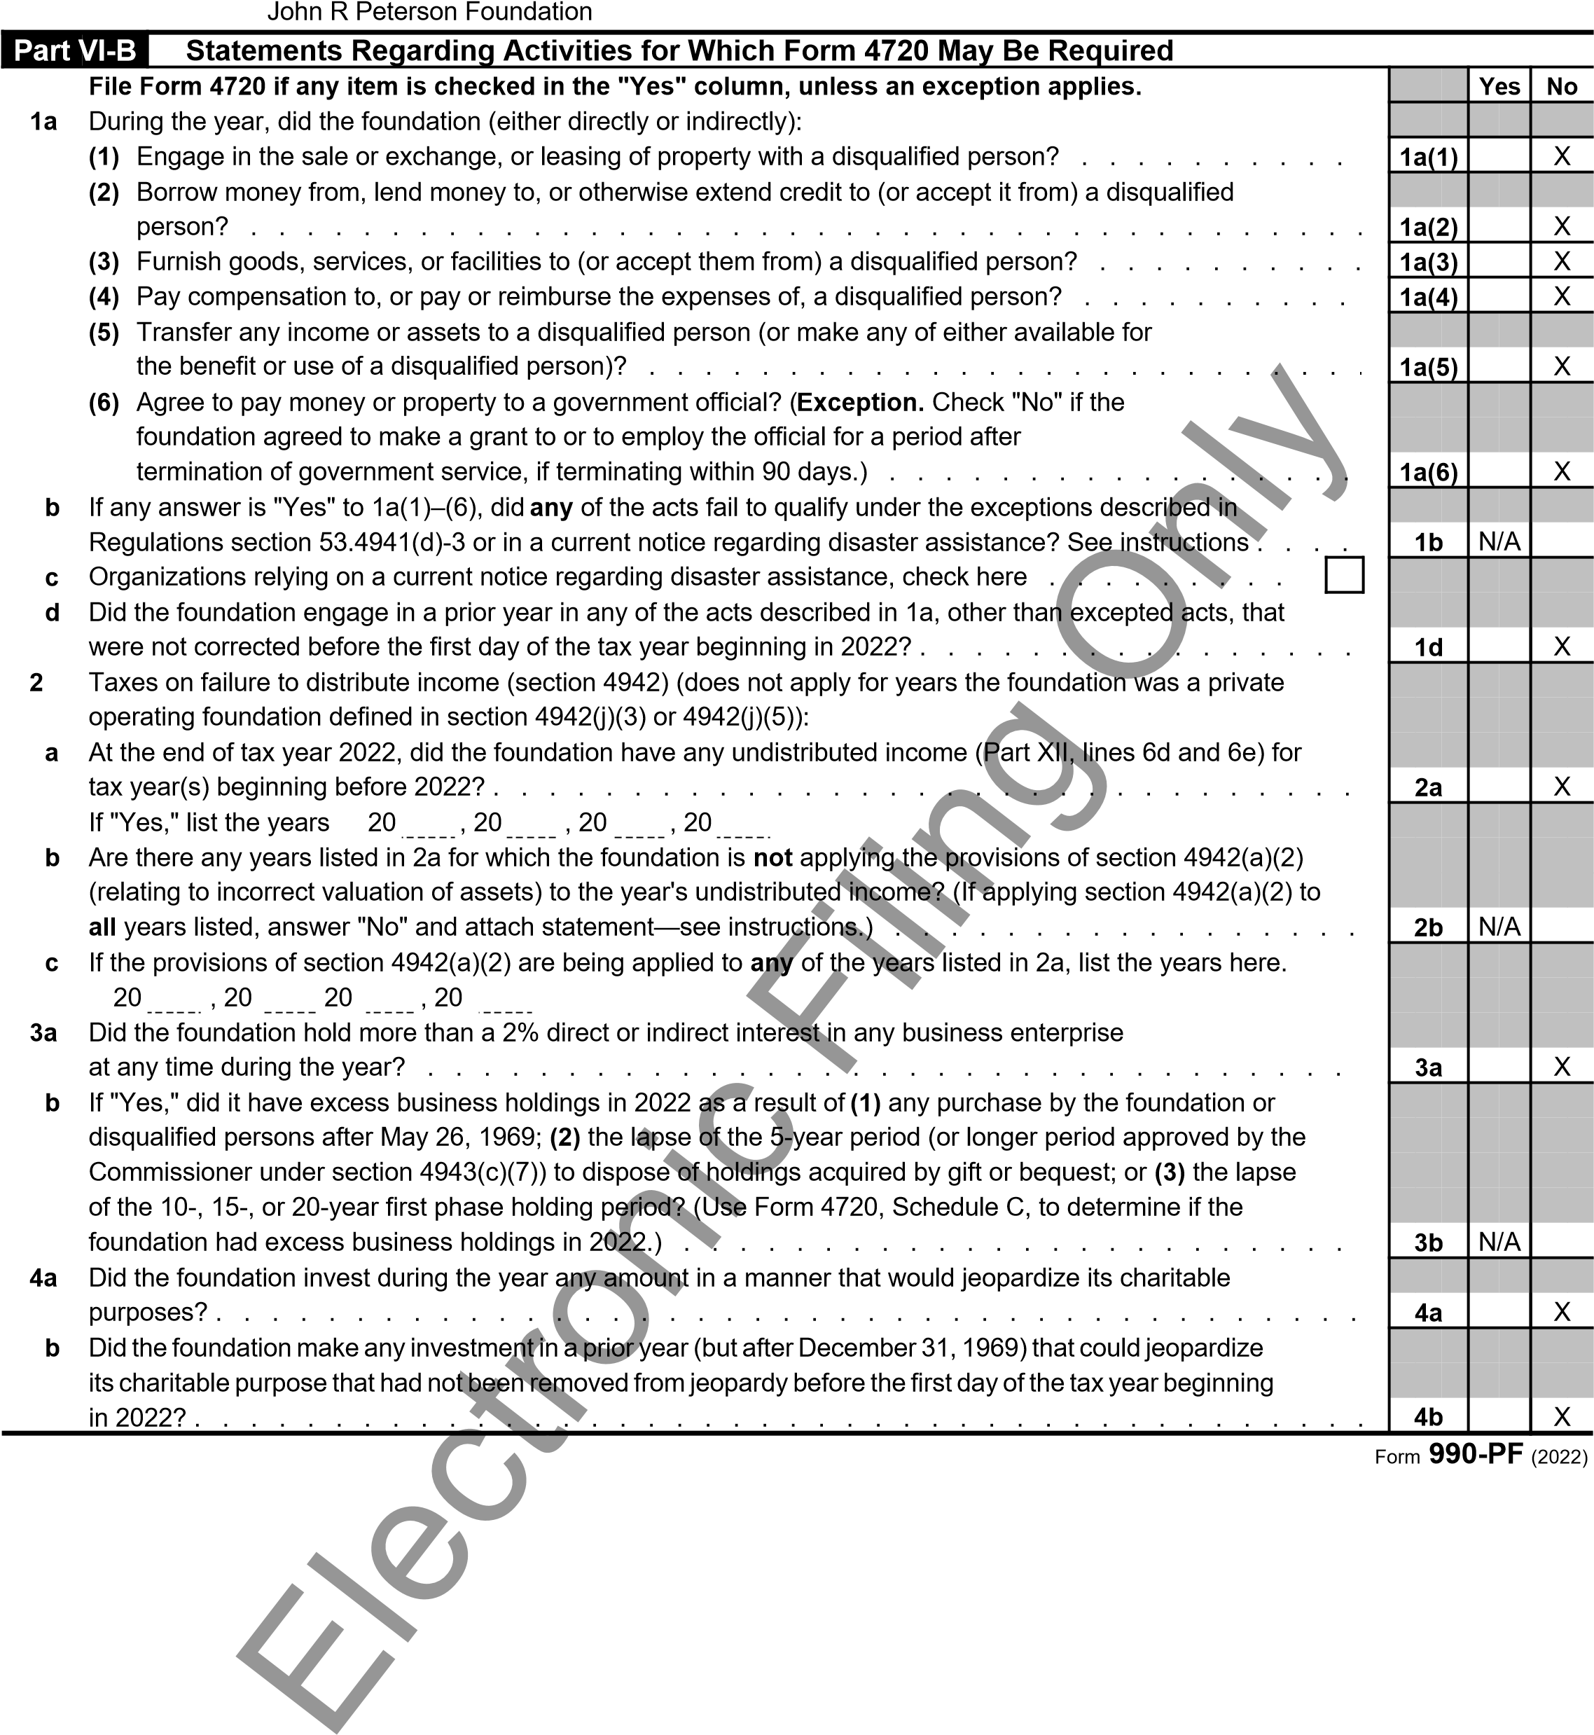

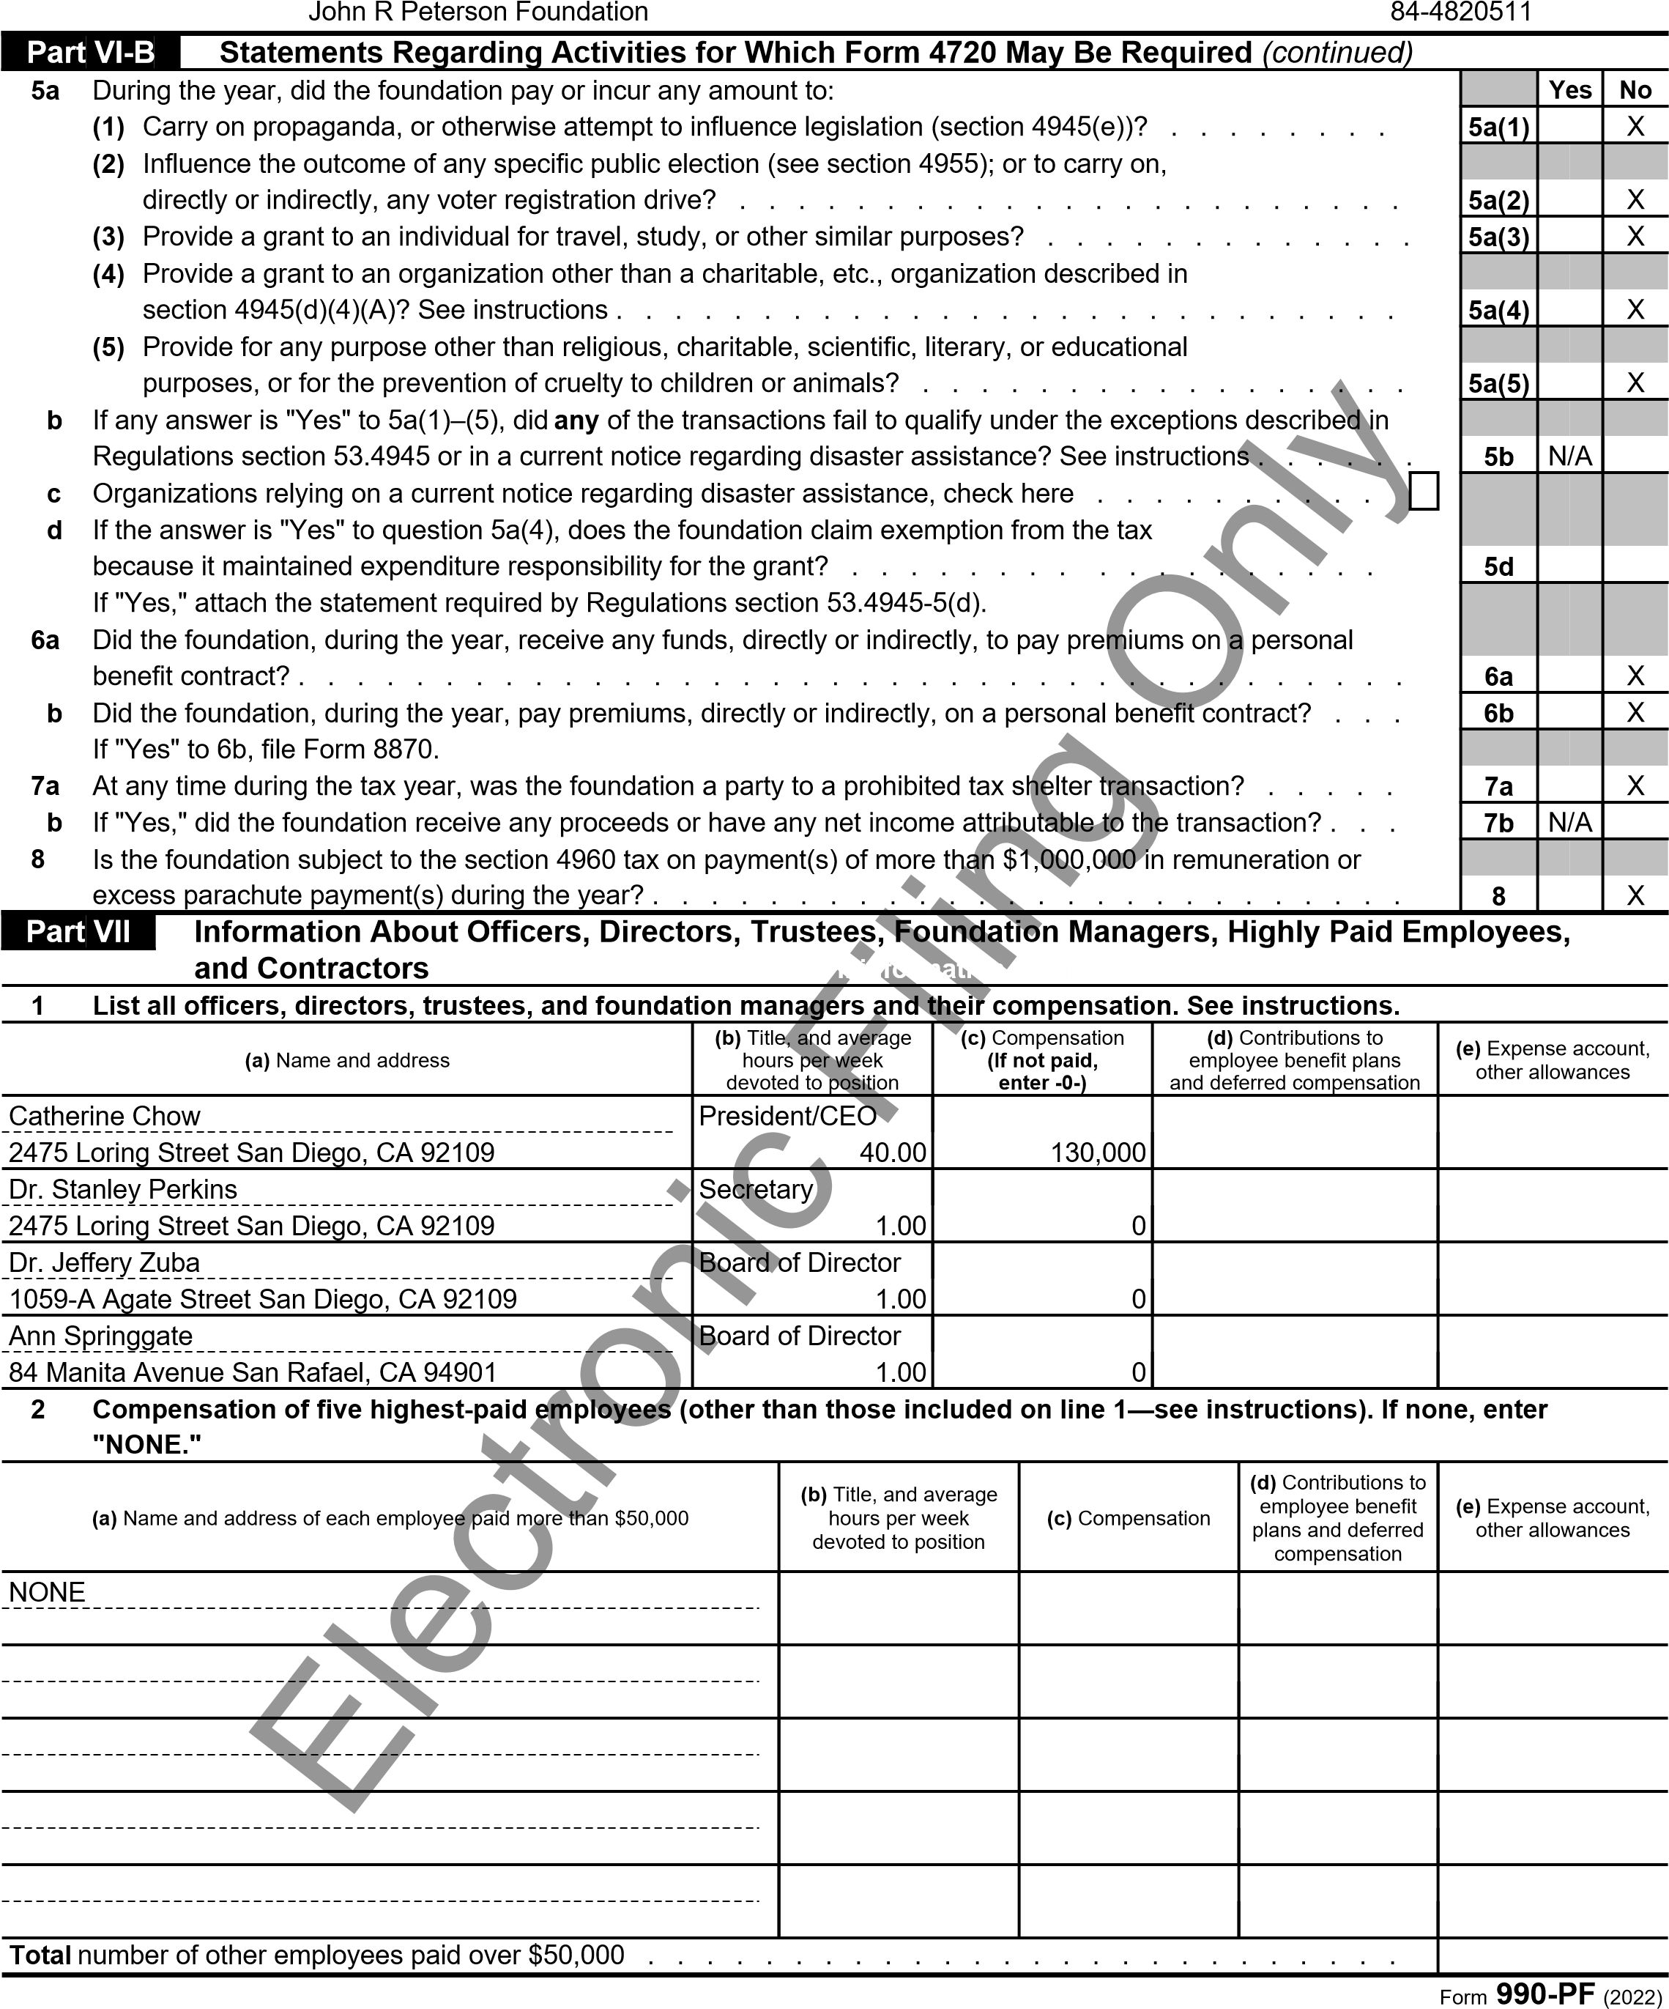

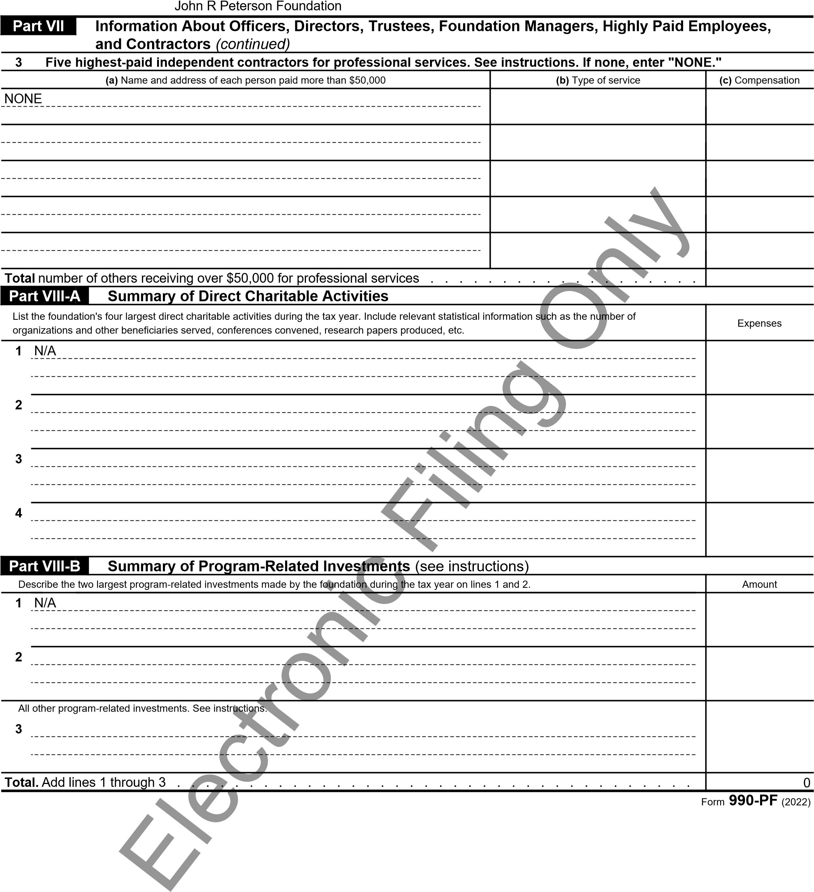

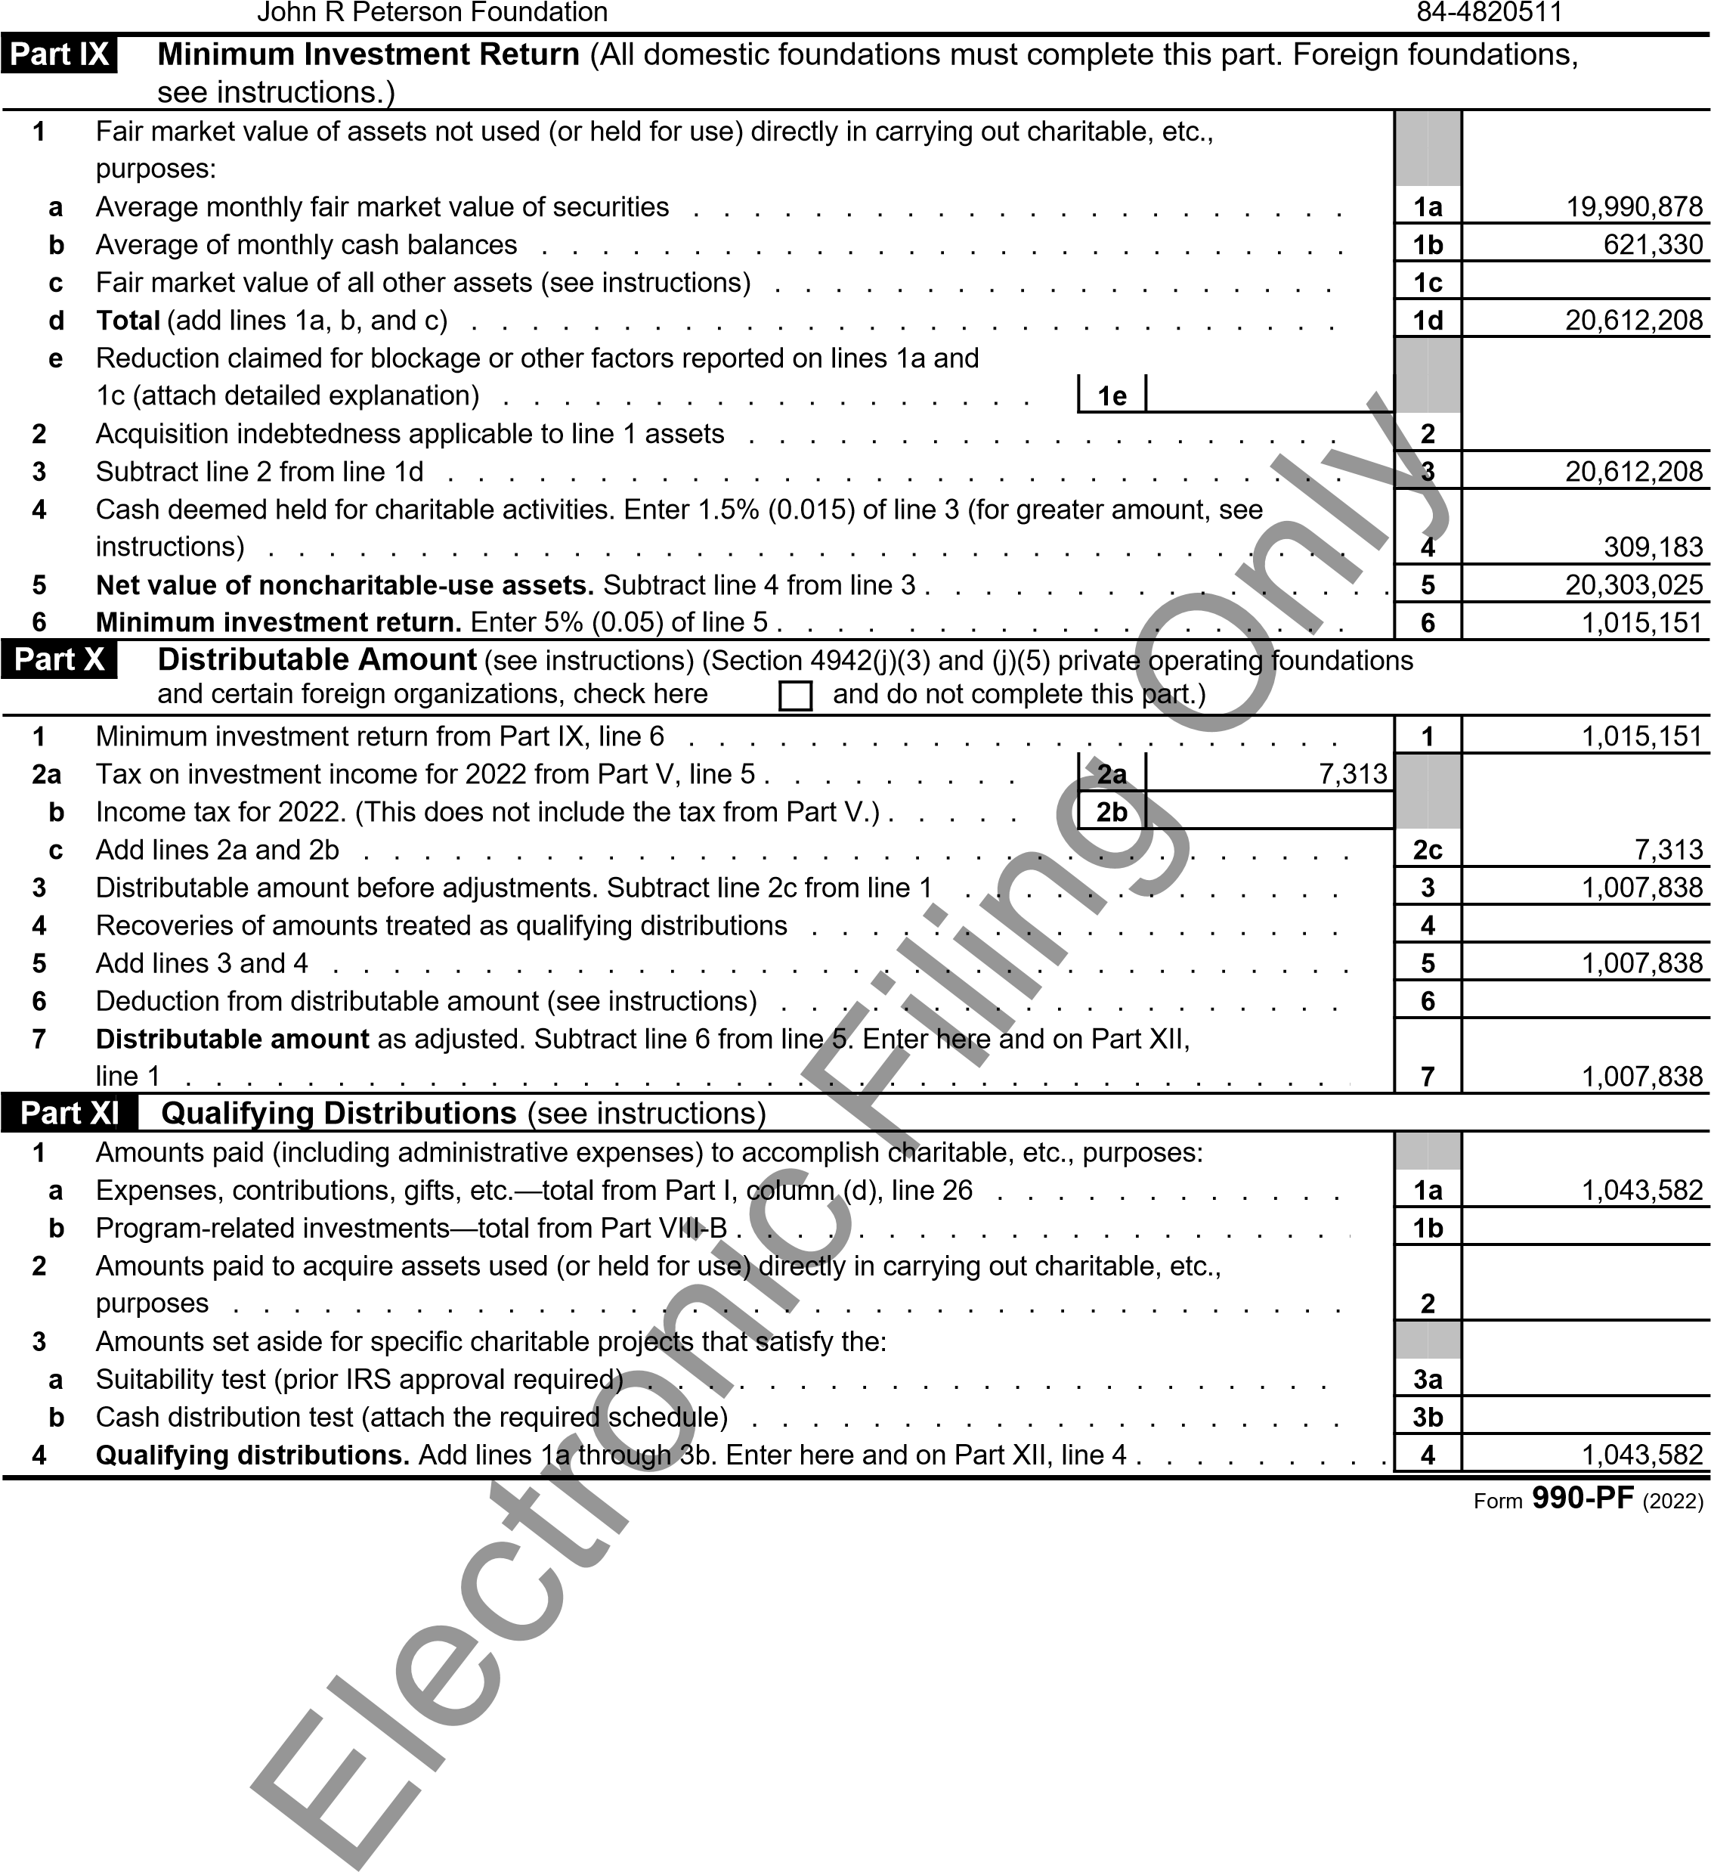

John R Peterson Foundation

|  |  |  |  |  |  |  |
| --- | --- | --- | --- | --- | --- | --- |
| **Part XII** | **Undistributed Income** (see instructions) | | | | | |
| 1. Distributable amount for 2022 from Part X, line 7 2. Undistributed income, if any, as of the end of 2022: 3. Enter amount for 2021 only . . . . . . . . 4. Total for prior years: 20 , 20 , 20   **3** Excess distributions carryover, if any, to 2022: **a** From 2017 . . . . . . . . . | | | **(a)** Corpus | **(b)**  Years prior to 2021 | **(c)**  2021 | **(d)** 2022 |
|  |  |  | 1,007,838 |
|  |  | 0 |  |
|  |  |  |  |
|  |  |  |  |
| **b** From 2018 . . . . . . . . . **c** From 2019 . . . . . . . . . **d** From 2020 . . . . . . . . . **e** From 2021 . . . . . . . . . **f Total** of lines 3a through e . . .  **4** Qualifying distributions for 2022 fr line 4: $ 1,043,582  **a** Applied to 2021, but not more tha **b** Applied to undistributed income of  (Election required—see instructio **c** Treated as distributions out of cor required—see instructions) . . . **d** Applied to 2022 distributable amo **e** Remaining amount distributed out  **5** Excess distributions carryover ap (If an amount appears in column ( amount must be shown in column  **6 Enter the net total of each colu indicated below:**   1. Corpus. Add lines 3f, 4c, and 4e. 2. Prior years' undistributed income. line 4b from line 2b . . . . . . 3. Enter the amount of prior years' u income for which a notice of defici been issued, or on which the secti tax has been previously assessed 4. Subtract line 6c from line 6b. Tax amount—see instructions . . . **e** Undistributed income for 2021. Su   4a from line 2a. Taxable amount instructions . . . . . . . . . **f** Undistributed income for 2022. Su 4d and 5 from line 1. This amount  distributed in 2023 . . . . . .   1. Amounts treated as distributions o to satisfy requirements imposed b 170(b)(1)(F) or 4942(g)(3) (Electio required—see instructions) . . . 2. Excess distributions carryover fro   applied on line 5 or line 7 (see ins   1. **Excess distributions carryover t** Subtract lines 7 and 8 from line 6  **10** Analysis of line 9: **a** Excess from 2018 . . . . . . **b** Excess from 2019 . . . . . . **c** Excess from 2020 . . . . . . **d** Excess from 2021 . . . . . . **e** Excess from 2022 . . . . . . | |  |
|  |
|  |
| 36,570 |
| . . . . . .  om Part XI,  n line 2a . . . prior years ns) . . . . . pus (Election  . . . . . . unt . . . . .  of corpus . .  plied to 2022  d), the same  (a).) . . . . **mn as**  Subtract line 5 Subtract  . . . . . .  ndistributed ency has on 4942(a)  . . . . . .  able  . . . . . . btract line  —see  . . . . . . btract lines  must be  . . . . . . ut of corpus  y section n may be  . . . . . .  m 2017 not tructions) . . **o 2023.** a . . . . . . | 36,570 |  |  |  |
|  |  |  |  |
|  |  |  |  |
|  |  |  |  |
|  |  |  | 1,007,838 |
| 35,744 |  |  |  |
|  |  |  |  |
| 72,314 |  |  |  |
| Electronic Filing Only | 0 |  |  |
|  |  |  |  |
|  |  |  |  |
|  |  | 0 |  |
|  |  |  | 0 |
|  |  |  |  |
|  |  |  |  |
| 72,314 |  |  |  |
|  |  |  |  |
|  |
|  |
| 36,570 |
| 35,744 |

Form **990-PF** (2022)

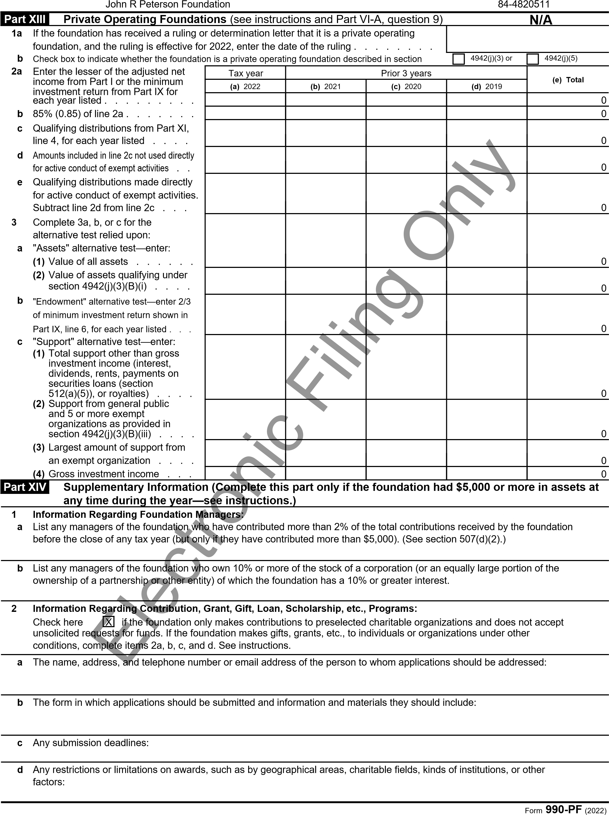

John R Peterson Foundation

|  |  |
| --- | --- |
| **Part XIV** | **Supplementary Information** *(continued)* **Enter information on 'Detail - Pt XIV, Ln 3a-b'** |

### 3 Grants and Contributions Paid During the Year or Approved for Future Payment

|  |  |  |  |  |  |
| --- | --- | --- | --- | --- | --- |
| Recipient | If recipient is an individual, show any relationship to  any foundation manager or substantial contributor | Foundation status of recipient | Purpose of grant or contribution |  | Amount |
| Name and address (home or business) |
| **a** *Paid during the year*  Aloha ʻĪlio Rescue  PO Box 492364  Keaau, HI 96749  Greater Good Charity  One Union Square  Seattle, WA 98101  San Diego Humane Society  5480 Gaines St  San Diego, CA 92110  Maui Humane Society  PO Box 1047  Puunene, HI 96784  Luck Dog Animal Rescue  5159 Langston Boulevard  Arlington, VA 22207  Kauai SPCA  PO Box 1018  Kilauea, HI 96754  PetFix Spay and Neuter  PO Box 384191  Waikoloa Village, HI 96738 | Electronic Filing Only | PC  PC  PC  PC  PC  PC  PC | Dog Food  Animal Welfare Grant/IT  Animal Welfare Grant  Animal Welfare Grant  Animal Welfare Grant  Animal Welfare Grant  Animal Welfare Grant |  | 485  566,041  150,000  46,000  90,000  40,000  20,000 |
| **Total** . . . . . . . . . . . . . . . . . . . . . . . . . . . . . . . . . . . . . . . . . | | | | **3a** | 912,526 |
| **b** *Approved for future payment* |  |  |  | |  |
| **Total** . . . . . . . . . . . . . . . . . . . . . . . . . . . . . . . . . . . . . . . . . **3b** | | | | | 0 |

Form **990-PF** (2022)

